

BRITISH COLUMBIA INSTITUTE OF TECHNOLOGY
School of Computing and Academic Studies | Lab#5
Program: Computer Systems Technology | COMP 7615 Cryptographic Methods
Instructor: Dr. Abhijit Sen | Due Date November 16th,2009

- Using RSA with CrypTool

- The demonstration material may be accessed through Indiv. Procedures>RSA Cryptosystem>RSA Demonstration… or Crypt/Decrypt>Asymmetric>RSA Demonstration… here will be presented a window with a series of options.
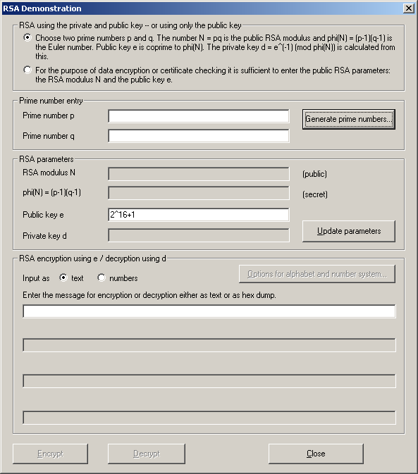

- Make sure that the radius option of using p and q is selected, not the N and e option.

- Next we shall enter some prime numbers for p and q. As thinking of large prime numbers can be a daunting task, the CrypTool has included a Prime number generator, this can be accessed by clicking the button Generate prime numbers… .Here make sure the option for independent values is selected

- The algorithm used does not really matter as they all produce prime numbers. For the lower value of each we shall use 500, and for the upper value, 1000. It is worth noting here that these limits may also be entered in the form of binary length, using the notation 2^x where x is the number of binary bits used to represent a number.

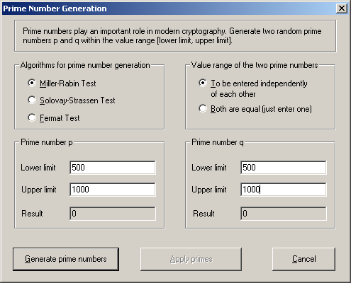

- Once all that has been completed click Generate prime numbers, and prime numbers will be generated, this may be clicked several times to generate different numbers.

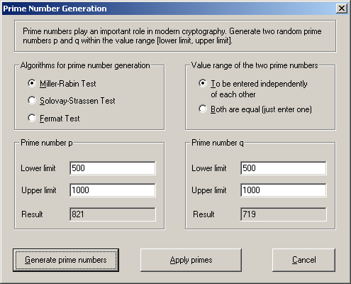

- Select Apply primes and these will be entered as the values for p and q. The values for N and will be automatically calculated. Now enter a value for e, this should be coprime to , if in doubt use a known prime number such as 13. Input a message as text, and enter a word or phrase you wish to be encrypted, and select Encrypt.

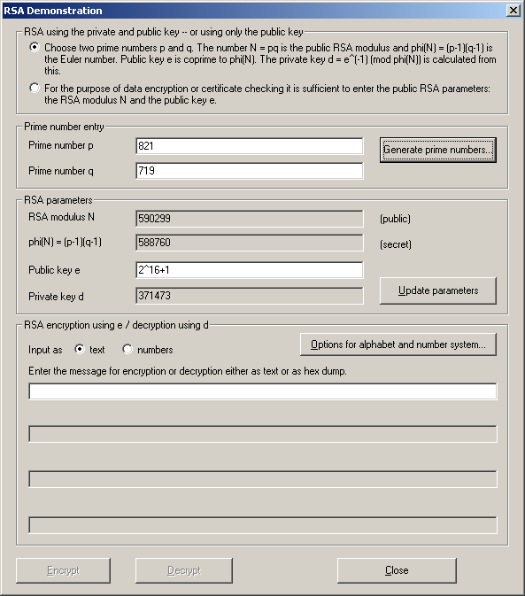

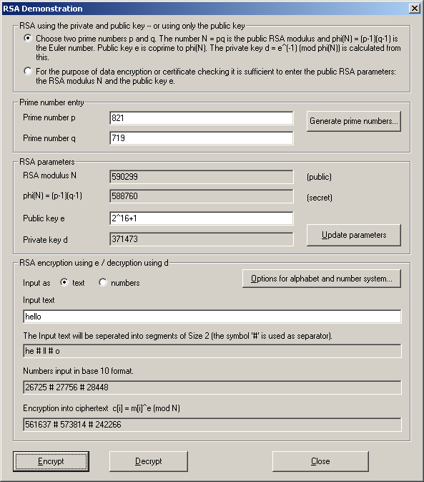

- Highlight and copy the encrypted numbers, in the above example these are:
561637 # 573814 # 242266
Your encrypted values will likely vary. Change the input type to numbers, and paste these numbers into the message input box (remember to include the separators, #).

Select Decrypt and you should see your original message deciphered.

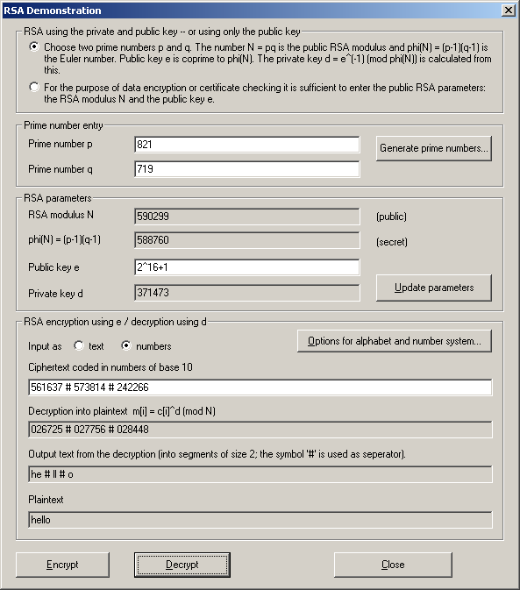

- Now, encrypt a message of your choice using the values:

p =59
q = 71
e = 13

Observe the results.

- Encrypt the same message with the values:
p = 673
q = 619
e = 13

- RSA Implementation

Next we shall encrypt a message using PKI. PKI (Public key infrastructure) includes users’ details in the encryption process as a form of authentication.
- Start by selecting Digital Signatures/PKI>PKI>Key Generation/Import… this is where you can create a pair of Asymmetric keys, one Public and one Private, using user details to do so. Here you may choose from three ciphers, RSA, DSA and Elliptic curve, we shall use RSA.
- Also, select a bit size of 512.
- Next, enter the user details requested on the right.
- Once all this has been done select Generate new key pair… At this point you may be required to move the mouse so as the system has some data to generate a random input.
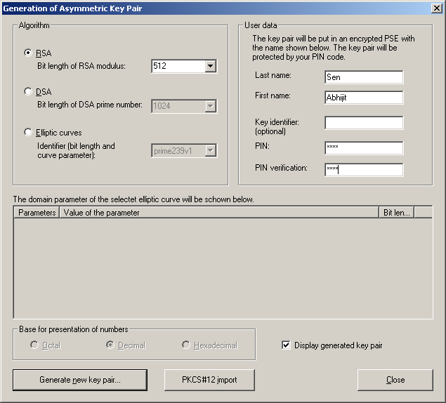

- Select Apply. You have just generated an Asymmetric key pair.

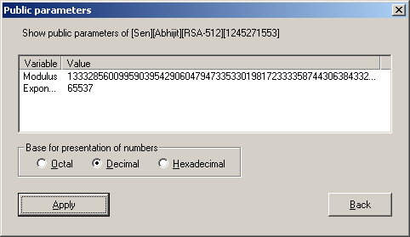

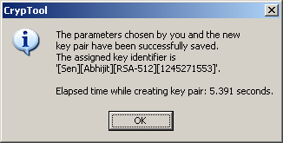

- To view this key and any other Asymmetric keys that have been generated, select Digital Signatures/PKI>PKI>Key Display/Export… This can also be used to view the details of each key and delete them if needed.
- Now that an Asymmetric key pair is available you may encrypt/ decrypt data using the RSA cipher.
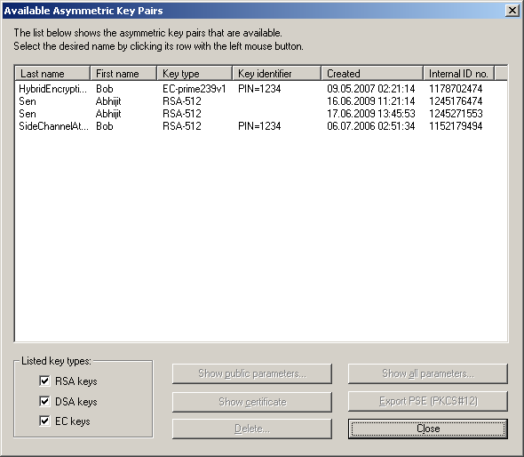

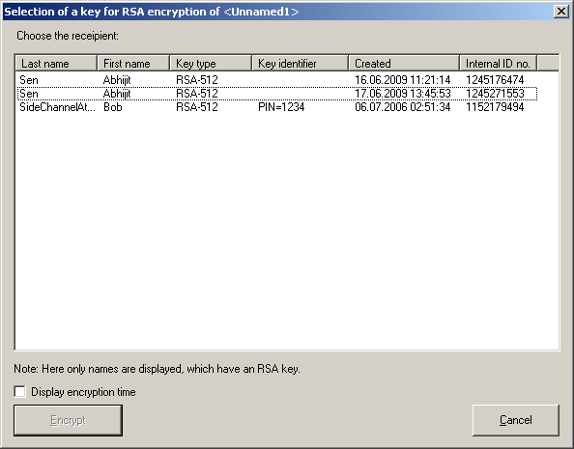

- Open a new text file with the CrypTool and enter some text you wish to encipher.
- Select Crypt/Decrypt>Asymmetric>RSA Encryption…
- Select your newly created key and Encrypt. The encrypted form of the text should appear.

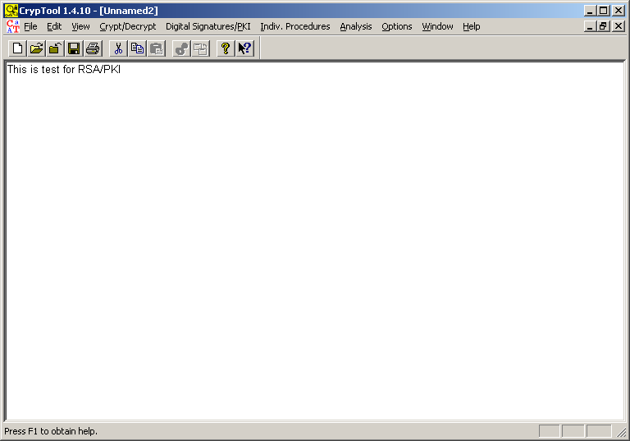
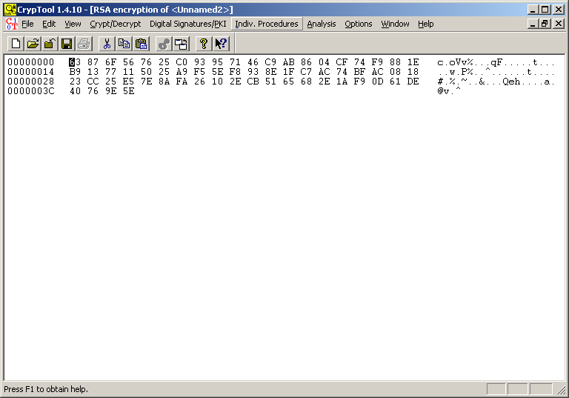

The encrypted data may be deciphered in a similar manner to other ciphers. Make sure the encrypted data window is active, then
- Select Crypt/Decrypt>Asymmetric>RSA Decryption… select your key and PIN, then Decrypt.
- Your message should be displayed but will likely have all the HEX representation shown as well

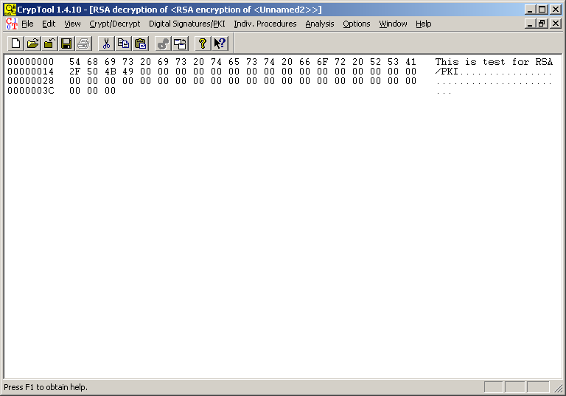

To remove the hexadecimal representation and display the message in a more Human legible way,
- Select View>Show as Text and should you wish to revert to the hexadecimal view select View>as HEX.

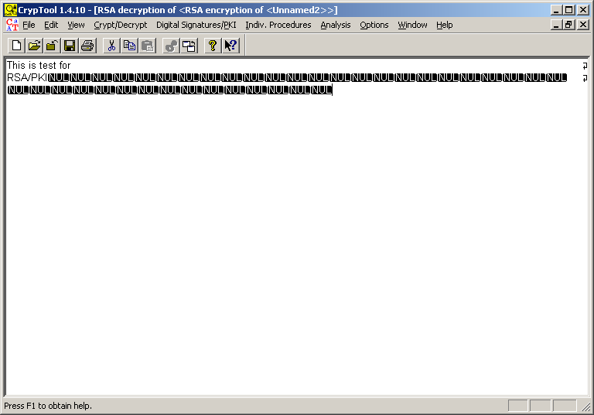

- Hybrid Cipher

The last cipher we will look into in this lab session is the Hybrid cipher, this combines aspects of both the AES and RSA ciphers. To encrypt a message with it,
- Select Crypt/Decrypt>Hybrid>RSA-AES Encryption… a GUI will be presented

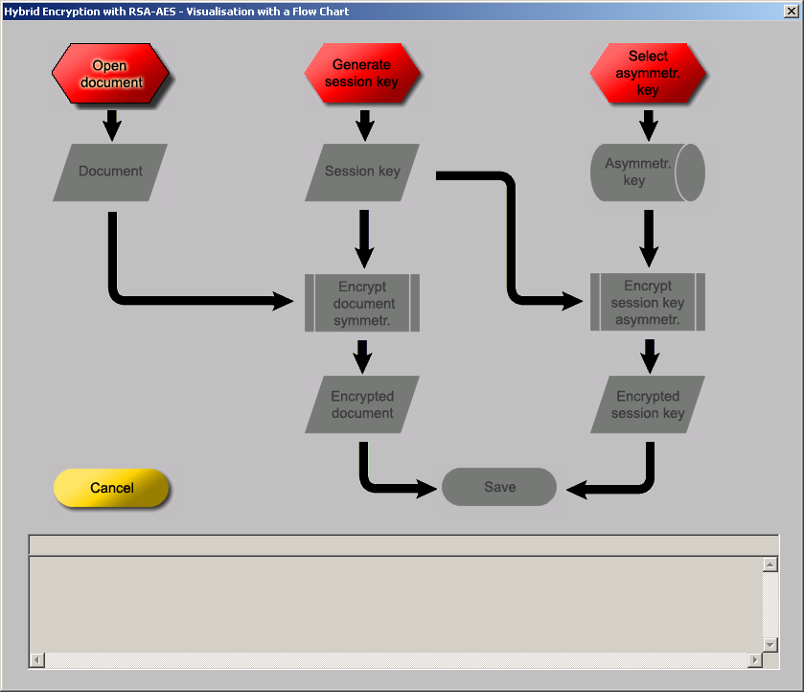

The above display is very effective as it demonstrates the processes of this cipher in a very easy to understand way.

- Begin by clicking on the Generate Session key button, you may be asked again to move the cursor for random input. Once successfully completed this button should turn green and the session key generated.

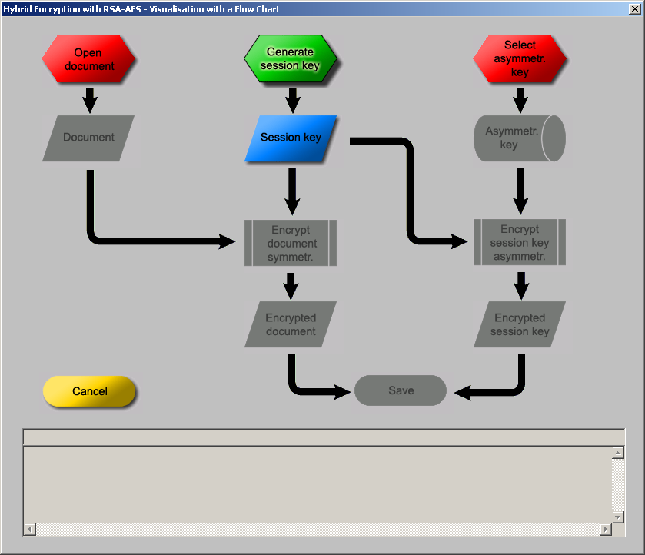

- Click on the Select Asymmetric key button and
- Choose the key you made during the RSA encryption.

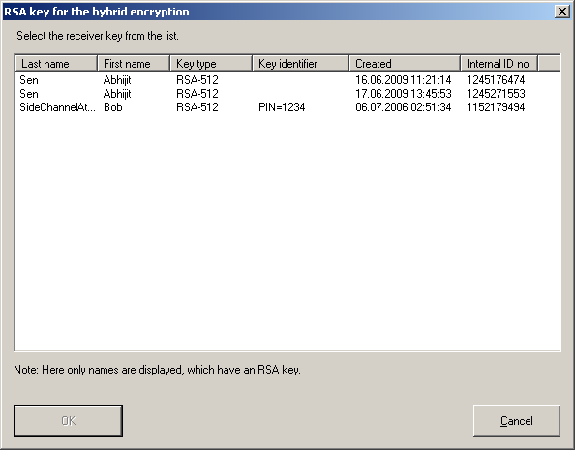

- Click on the remaining two red boxes, and
- select Save.

You should now see your data encrypted with the Hybrid cipher,

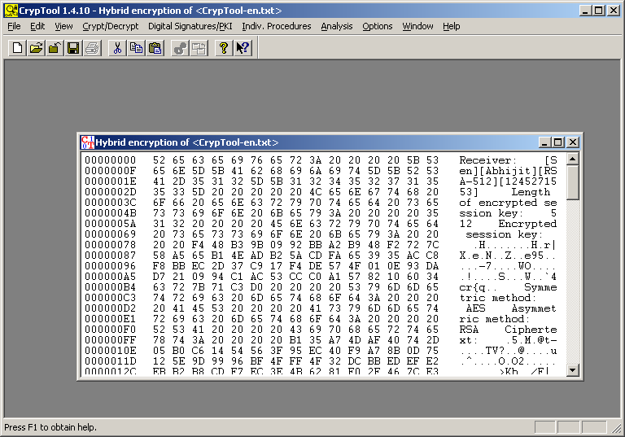

- To decrypt it select Crypt/Decrypt>Hybrid>RSA-AES Decryption…, at this terminal select Continue, then select the appropriate key and enter its PIN number, select Continue once more and then Decrypt.

The following shows some of the screen shots.

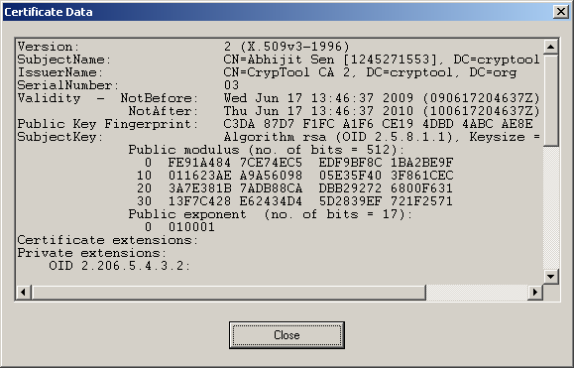

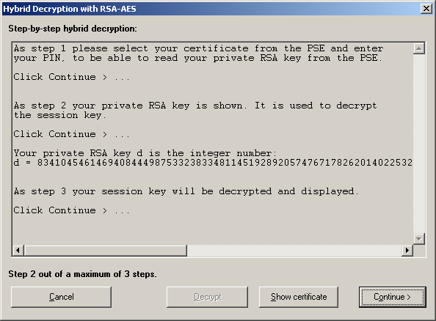

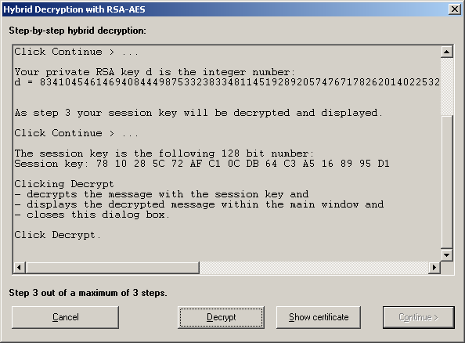

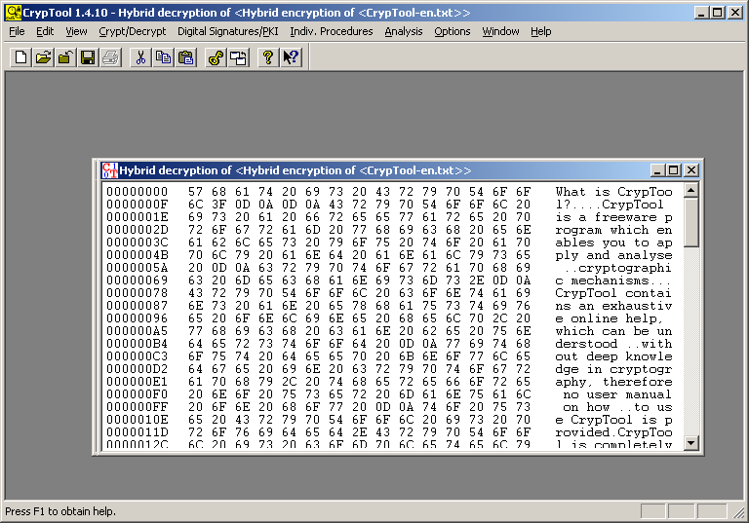

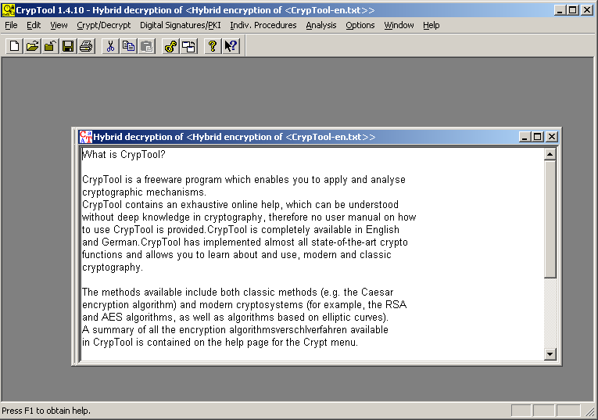

- Submission Requirements:

Please submit the document in the share drive.

Submit a professionally formatted report (Word document) containing the following:

- Cover page with your:
  - full name
  - email address
  - student id number
  - Lab #
  - Date of Submission
- Section 1:Purpose:
- Section 2:Procedures: Step by step description of your procedures with Screen Shots
- Section 3:Discussion: Clearly discuss the result and your observations
- Section 4 Conclusion

Name the word file as :

Crypto_L5_ Lastname_Initial.doc

NOTE : For your final submission USE ONE OF THE SAME TEXTS AS IN LAB 1.

